**COMPANY PROFILE**

**i. Introduction**

**Name of Company:** Menon Piston Ltd.

**Location:**-

|  |  |  |
| --- | --- | --- |
| Address: | Menon Piston Limited Plant II, H-1, MIDC, Kupwad Block, Sangli -416416. Maharashtra, India. |  |
| Telephone: | **0233-2645179, 2645189, 3293008** |
| Fax: | **0233-2644510** |

**Email address**:- [mplpl2@rediffmail.com](mailto:mplpl2@rediffmail.com)

**No. of Staff: 150** -Technical, **75**- Non Technical

**No. of workers:** **225** Workers.

**Work Shifts:**  There is **3** shifts per day. Production is carried in all **3** shifts continuously.

**Turnover: 32** Crore/ Annum.

**Company History:-**

The company history was incorporated on 25/08/1977 as private ltd. Company in the name of Menon Pistons Ltd. In the state of Maharashtra. Due to increase in turnover in company the company became deemed public company on 15/06/1998 and the name of company is changed to Menon piston ltd. On 25/06/1998 and 10/11/1994 the company was converted into a flanged public company wide special resolution passed on 10/11/1994.

The company promoted by Mr. Ram Menon and Late Mr. Chandran Menon was incorporated in 1977 and has been manufacturing pistons for more than 13 years has been consistently making profits. The company has been catered to small diesel engine manufacturing. Subsequently company started supplying the high added piston required by the automobile industry and diesel engine sector but selected segment of heavy duty industrial pistons since the existing big pistons manufacturers was not interested in this field due to small no of pistons required for cars, LCVs/HCVs. Now major customers include Kirloskar, Cummins Ltd., Escorts Ltd., and Eicher Tractors Ltd. Besides aluminium alloy pistons it manufactures piston rings and pins for various automobiles and various industrial engine applications.

The company has got ISO 9002 certificate.

**Mission & Core Values:-**

* VISION

To be the world’s leading provider of auto component manufacturing & total engineering solutions to automobile manufacturers across the world.

* MISSION

To provide innovative products of world class quality at reasonable prices.

* QUALITY POLICY

Primary responsibility at Menon Pistons Limited is to offer cost effective quality products to its customers.

**Research and Development:-**

Many applications require high hardness at surface & also core strength & toughness to withstand impact stress. To achieve this property, process used to includes carburizing, cyaniding, nitrating and carbonitriding. In carburizing process, carbon is diffused into parts surface to a controlled depth by heating part in carbonaceous media.

With this arrangement, Menon Piston Ltd. will have to access in the latest Piston Technology, high strength materials, equipment and machinery for Design/Development and manufacture of pistons to cater to the needs of manufacturers to satisfy their requirements of Piston designs with and without “Cooled Gallery: to comply with the emission legislations prevalent and those in the offing future. To satisfy the demands of the engine manufacturers for low pollution and high efficiency, Menon Piston Ltd have been putting a lot of efforts to produce Pistons with light weight, high intensity and low friction by performing checks for structural design of Pistons, analysis of internal stress, mechanical and Thermal load and verification of Pistons of Designs by three dimensional finite element method in co-operation with their partner M/s, Dong Yang Piston co. Ltd.

**Product Range:-**

In 1985, Menon Piston Ltd set up its Second Plant in Sangli which is around 60 kilometres from Kolhapur and manufacturers around 200,000 Pistons annually primarily for catering to the Diesel engines for Industrial purposes, irrigation/Agricultural and Small Diesel Generator Sets.

Apart from the manufacturers of Pistons, this plant is fully equipped to manufacture Gudegon Pins in the diameter range of 16mm to 18mm, with well supported Laboratory and sophisticated manufacturing and measuring equipment to heat treat/Machine/Grinder/Super finish Gudegon Pins guaranteeing the geometrical accuracies and mechanical strength/hardness for long and trouble free operation on the engine. Menon Piston Ltd’s product Range boasts of piston assemblies for diverse array of high Tech features catering to the wide variety of applications. Such as

**1. Heavy Duty Diesel Engines for Power Generation/Off Highway Vehicles/Gas Engines.**

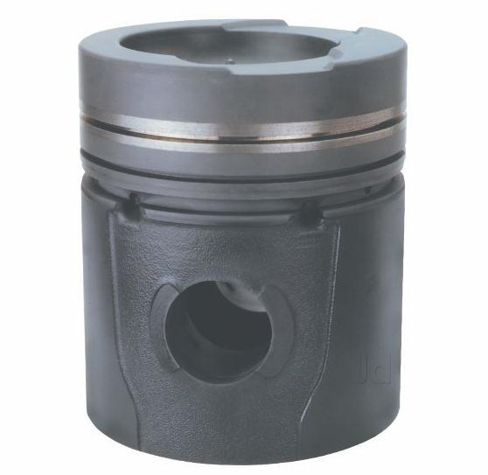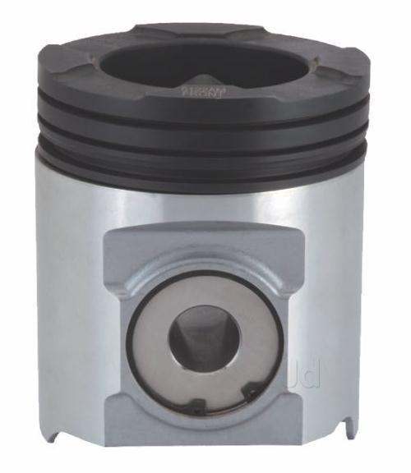

MW Piston Articulated Piston

For Heavy Duty Diesel Engines for Power Generation/Off Highway Vehicle applications, MENON PISTON LTD develop and produce Pistons with diameters ranging from 130mm to 190mm featuring Single Alfin and Dual Alfin Gravity Die Cast Pistons. MENON PISTON LTD manufacture these Piston on a dedicated manufacturing facility with special purpose CNC Machines to produce complex OD profiles, and

Pin bores with Oval Bore, trumpet bore or relief’s as per the requirement. The complicated Core Profiles featuring on this Piston are generated applying 3D modelling facilities using Pro-E Wildfire-2 foundation package for surface modelling, advanced modelling extension and Tool Design Package for manufacturing to achieve targeted sections and effective control on the weight of the Piston for optimum balance of reciprocating masses. Some of the special features which are provided in the design of these bigger size Pistons (Diameters of 110mm to170mm range)

**2. Heavy / Medium/ Light Commercial Vehicles with Diesel Engines.**

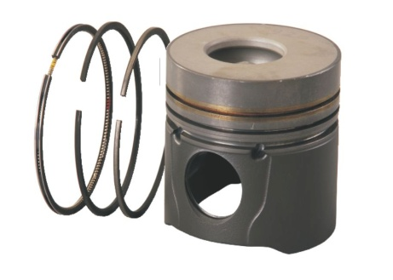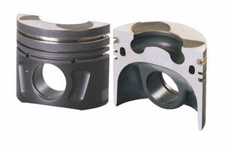

TATA 4SP Euro III Piston Cooled Gallery Cut Section

In view of the ensuring legislations and the keenness of the Government to provide environmentally friendly ambience, the modern Internal Combustion Engines need to introduce New Technologies for complying with the emission legislations.

Menon Piston Ltd Manufactures wide range of Pistons in the diameter range of 75mm to 130mm with and without “Cooled Gallery” features. The design and manufacturing facilities available with Menon Piston Ltd enables them to design produce and optimize the features such as, “as cast Oil drain Pockets”, Autothermic Piston with ‘control expansion”, Steel struts to provide lesser fittng clearences for reduced noise levels , Gudgeon Pin Bore offset for effective load balancing/noise control, & Cooled Gallery Pistons.

**3. Bi- wheeler (4 Stroke) / Small Engine Applications**

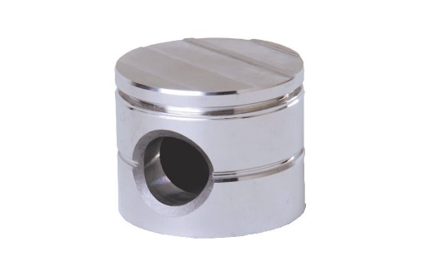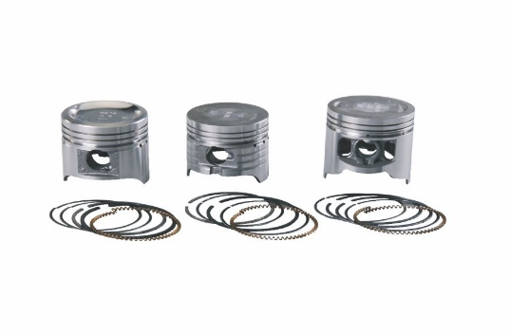

Copeland Pistons

TVS Victor/ Boxer

A wide range of Pistons for 2 stroke and 4 stroke engines in the diameter range of 40 to 60 mm for powering the Scooter, Motor cycles and Refrigeration Air Compressors are made from Eutectic and Hypereutectic Aluminium Alloy which are very cost effective and provide value for the money.

These pistons are offered in attractively packed containers as assemblies consisting of Pistons, Gudgeon Pin. Menon Pistons Ltd produces about 1.3 million pistons annually of 41 mm diameter for Refrigeration Air compressor sealed units. These are manufactured on special purpose machines with close tolerance and extremely good surface finish to provide ‘Quite’ running of the compressors.

**4. Gudgeon pins.**

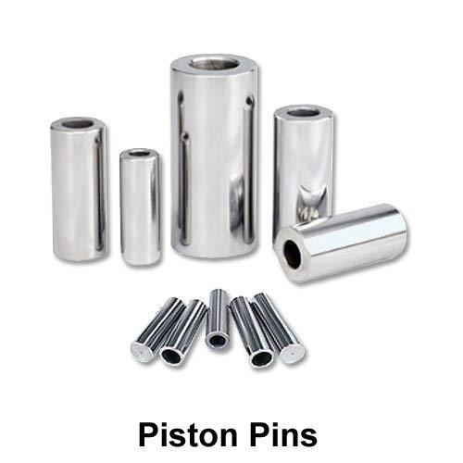

Gudgeon pins

They mainly manufactured pistons. Pistons rings & gudgeon pins. They are Vander for 13 companies from which major are automobile companies. They supply pistons for Telco, Bajaj, Mahindra & Kirloskar oil Engines & Cement Diesel Engines, Cummins India Ltd.

**Customers:**

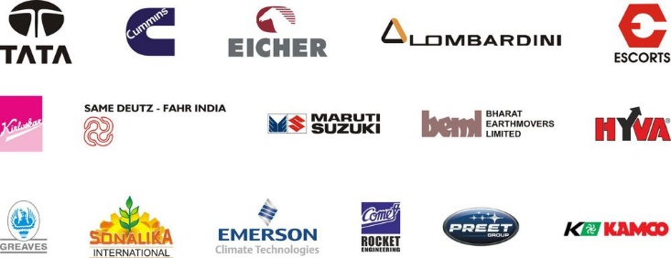

**Awards & Laurels:-**

* The first company in India to develop ring carrier pistons.
* Best vendor awards from Maruti Udyog ltd in the 1994-95.
* “ship – to – use” status by Cummins India ltd since 1995.
* Faster development award from Kirloskar oil engines Ltd.
* ISO/TS: 16949 certified by Tuv Suddeutschland in 2015.
* Outstanding supplier for excellent performance award from Cummins group in July 2006.

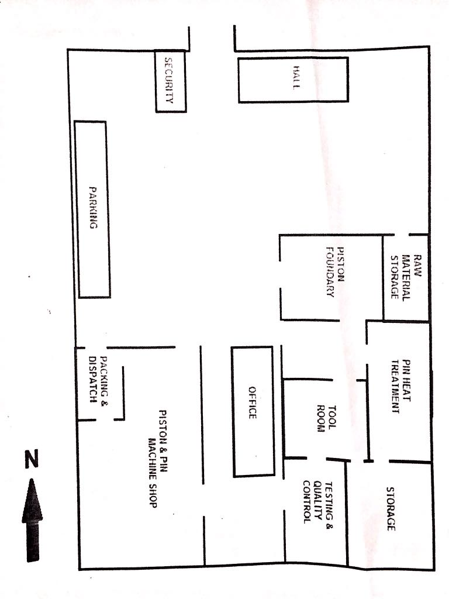**ii. LAYOUT**

Company Layout